Change Broadband Service Tier Over Cable

Version Control:

Use Case Name: |  | Change Broadband Service Tier Over Cable
Use Case Owner: |  | Sumit Borade
Current Version |  | 0.4
Use Case Version History
Modified Date | Version |  | Modified By | Change Description
June 28, 2009 | 0.1 |  | Tom Schnarr | Initial Version
July 8, 2009 | 0.2 |  | Tom Schnarr | Added logic for Future Dated support
July 9, 2009 | 0.3 |  | Tom Schnarr | Revised some logic – correct syntax error
August 26,2009 | 0.4 |  | Sumit Borade | Updated to add the Reply step and removed steps not relevant to SMP

Brief Description:
This use case describes the process by which a YouSee subscriber orders a change to their broadband services and how the service is changed.

The use case is written from the perspective of the SMP provisioning solution.

Related Documents
- YouSee SMP SOW2Architecture Requirements Document
- YouSee SMP SOW2 Business Requirements Document
- Voice over Cable Use Case Activation
- Cisco BACC TC Specification
- CISCO Subscriber Manager TC Specifications

Related Use Cases

Pre-Conditions
- Subscriber is an active broadband over cable subscriber.

Post-Conditions
- Subscriber is able to use the broadband service at their desired service tier.

Use Case

Primary Flow Diagram
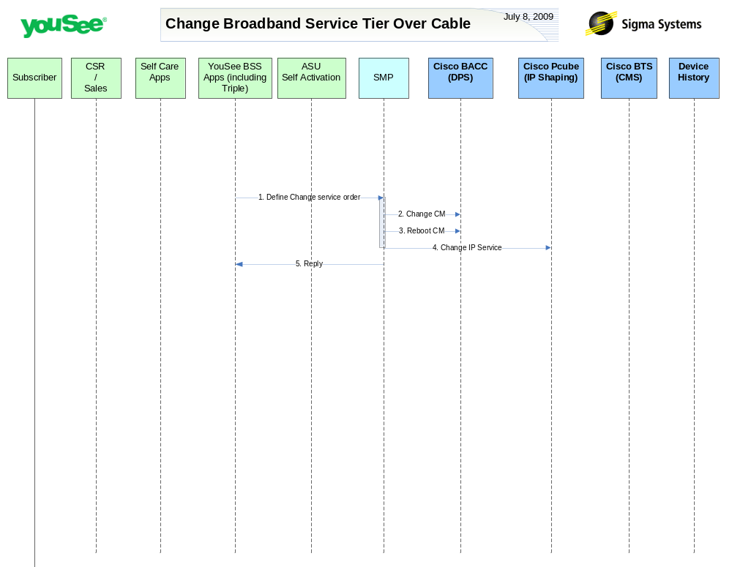

Primary Flow Detail
# | Actor: Key Action | Description | Alternate Flows/Details
Note: The following steps in the use case occur on the time of activation of the change order.
 | YouSee BSS: Order is communicated to SMP to change Broadband Service Tier | The BSS components perform a variety of qualification and product catalog decomposition and communicate an order to SMP updated broadband services as ordered by the customer.  YouSee BSS (Triple) will communicate the order to SMP through SMP’s OSS/J Order Management API. Triple will provide logical services and service attributes. SMP will be required to translate these service/service attributes to engineering level resources and resource attributes.
 | SMP: modifies CM in BACC | SMP will change the configuration of the CM in BACC
 | SMP: requests BACC to reboot the CM Device | SMP will then request BACC to reboot the CM device resulting in the CM getting the new configuration, MTA to go offline and CPE to be assigned a new public IP Address.
 | SMP: modifies internet service to CISCO Subscriber Manager | SMP will change the configuration for this CM in CISCO Subscriber Manager
 | SMP: Replies back to ASU the status of Activation | SMP will reply to ASU the status of Provisioning Order to ASU. | If Provisioning fails then SMP will put the Failed task in Manual Queue.

